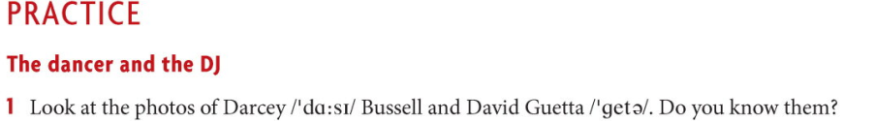
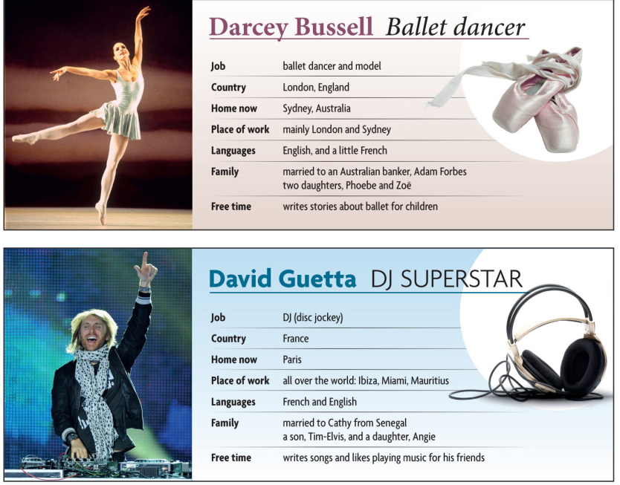
Read the given information.
Write full sentences using Present Simple Tense.
Eg. Darcey is a ballet dancer. She comes from London, England.
David is a DJ. He comes from France.

2 Read and translate the following text. Make 5 questions to the text. Use Present Simple Tense.
